**@ca.worldsign.org**

# Adding user01~05

# apt-get install dovecot-imapd sensible-mda sendmail sasl2-bin

# vim /etc/default/saslauthd



# vim /etc/mailname



# vim /etc/mail/local-host-names



# vim /etc/mail/access //상대 도메인 사용자와 메일 송-수신 가능하도록 relay 설정



# vim /etc/mail/sendmail.mc



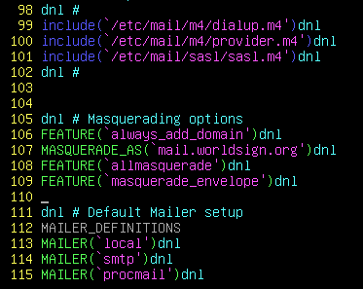

# sendmailconfig

# systemctl restart sendmail

# netstat –nl | grep 25

# vim /etc/dovecot/conf.d/10-auth.conf



# systemctl restart dovecot